**Prepare Yourself for an Earthquake!**

**Tokyo Metropolitan Government ,Katsushika Ward and Sumida Ward Comprehensive Joint Disaster Management Drill 2016**

**Volunteer interpreters will assist in English and Chinese**

Date: Sunday, September 4, 2016

Time: 9 a.m. to 12 noon

Place: Mizumoto Park, Katsushika Ward (Mizumotokoen3, Katsushika Ward)

(get on the Keisei bus from Kanamachi Station on the JR Line to “Mizumoto koen” bus stop, and then 15-minute walk from “Mizumoto koen” bus stop)

A strong earthquake could strike Tokyo or its surrounding areas at any time.

Come to the main drill site of Tokyo’s largest annual earthquake drill to learn how to prepare you and your family.

* Observe simulated rescues from collapsed buildings, restoration of lifeline services, and other drills and demonstrations.
* Visit exhibit booths to learn more about disaster preparedness.
* See special emergency response vehicles and rescue dogs up close.

Interpriters are in...　『Bureau of Citizens and Cultural Affairs（）』Booth

in exhibit and experience area（・）

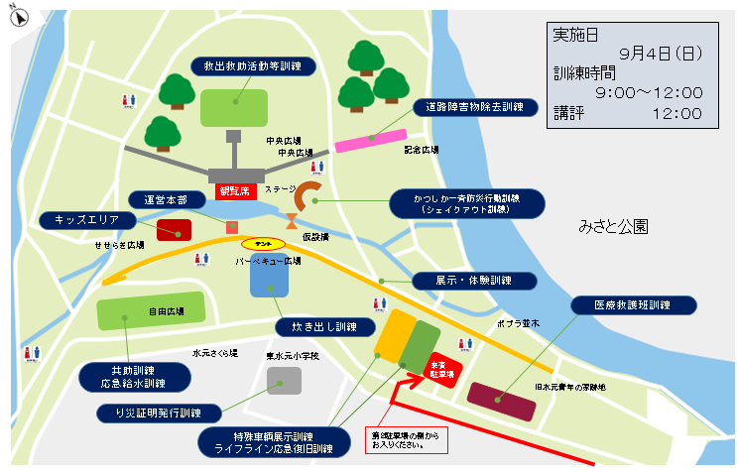

Citizens’ Affairs Division

Community Activity Promotion Section

Bureau of Citizens and Cultural Affairs

Tokyo Metropolitan Government

TEL:03-5320-7738

『Bureau of Citizens and Cultural Affairs（）』Booth

To : Community Activity Promotion Section

Citizens’ Affairs Division

Bureau of Citizens and Cultural Affairs

**Comprehensive Joint Disaster Management Drill**

**Participation Reply Form**

Please complete and return this form by **August 31, 2016(Wed.)** to

Fax: **03-5388-1331** or

E-mail: [S8000224@section.metro.tokyo.jp](mailto:S8000224@section.metro.tokyo.jp)

Your Name：

The Number of Participant：

Your Language (Please circle one of the languages)：　English　 　Chinese

Phone number： 　 　 Fax number：

E-mail：

The following person(s) will attend:

Name: Name:

Name: Name:

Name: Name:

Name: Name:

**Scenes from former Drill**

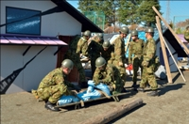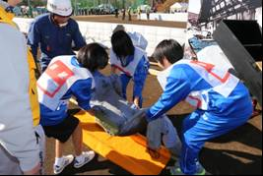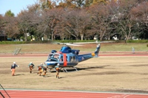

Don’t miss out on this unique opportunity!

Learn how to help yourself and others in an earthquake!